PRACTICAL NO.8
Programs on Services, notification and broadcast receivers

Service:
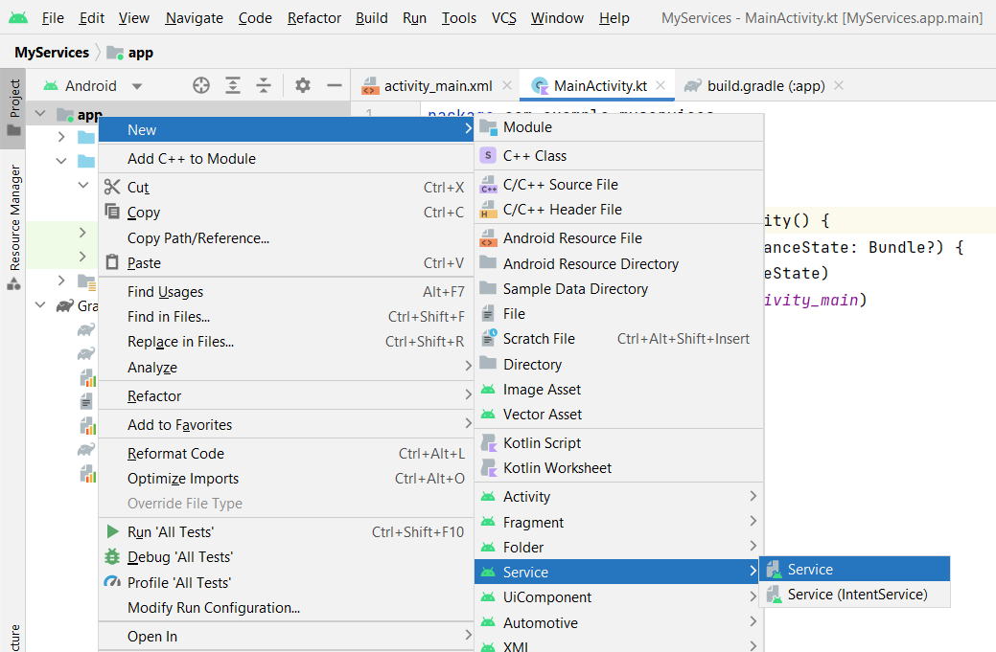
Code:
activity_main.xml
<?xml version="1.0" encoding="utf-8"?>
<androidx.constraintlayout.widget.ConstraintLayout xmlns:android="http://schemas.android.com/apk/res/android"
xmlns:app="http://schemas.android.com/apk/res-auto"
xmlns:tools="http://schemas.android.com/tools"
android:layout_width="match_parent"
android:layout_height="match_parent"
tools:context=".MainActivity">
<TextView
android:layout_width="wrap_content"
android:layout_height="wrap_content"
android:text="Hello World!"
app:layout_constraintBottom_toBottomOf="parent"
app:layout_constraintEnd_toEndOf="parent"
app:layout_constraintStart_toStartOf="parent"
app:layout_constraintTop_toTopOf="parent" />
</androidx.constraintlayout.widget.ConstraintLayout>

MainActivity.kt
package com.example.myservices
import android.content.Intent
import androidx.appcompat.app.AppCompatActivity
import android.os.Bundle
class MainActivity : AppCompatActivity() {
override fun onCreate(savedInstanceState: Bundle?) {
super.onCreate(savedInstanceState)
setContentView(R.layout.activity_main)
var myservice=Intent(this,MyMusicService::class.java)
startService(myservice)
}
}

MyMusicService.kt
package com.example.myservices
import android.app.Service
import android.content.Intent
import android.media.MediaPlayer
import android.os.IBinder
import android.widget.Toast
class MyMusicService : Service() {
override fun onBind(intent: Intent): IBinder {
TODO("Return the communication channel to the service.")
}
override fun onCreate() {
super.onCreate()
var mc:MediaPlayer= MediaPlayer.create(this,R.raw.newmusic)
mc.start()
}
override fun onDestroy() {
super.onDestroy()
Toast.makeText(applicationContext,"Service End",Toast.LENGTH_SHORT).show()
}
}

Output:

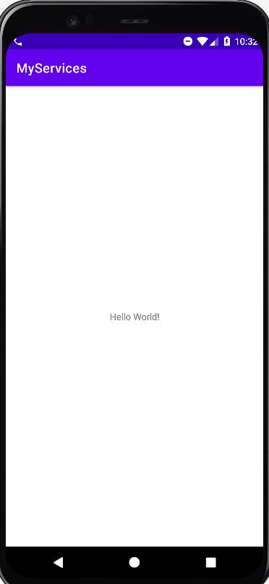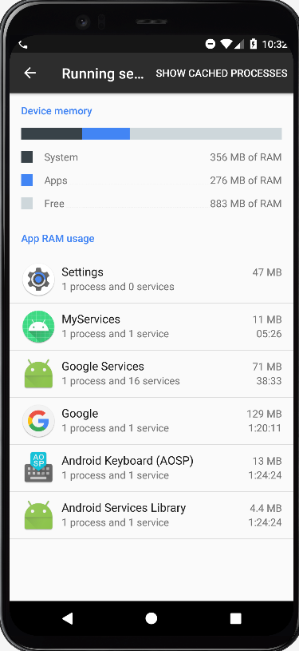

Notification
Code:

activity_main.xml
<?xml version="1.0" encoding="utf-8"?>
<androidx.constraintlayout.widget.ConstraintLayout xmlns:android="http://schemas.android.com/apk/res/android"
xmlns:app="http://schemas.android.com/apk/res-auto"
xmlns:tools="http://schemas.android.com/tools"
android:layout_width="match_parent"
android:layout_height="match_parent"
tools:context=".MainActivity">
<Button
android:id="@+id/button"
android:layout_width="wrap_content"
android:layout_height="wrap_content"
android:text="Notification"
app:layout_constraintBottom_toBottomOf="parent"
app:layout_constraintEnd_toEndOf="parent"
app:layout_constraintHorizontal_bias="0.498"
app:layout_constraintStart_toStartOf="parent"
app:layout_constraintTop_toTopOf="parent"
app:layout_constraintVertical_bias="0.143" />
</androidx.constraintlayout.widget.ConstraintLayout>

MainActivity.kt
package com.example.notificationpract
class MainActivity : AppCompatActivity() {
override fun onCreate(savedInstanceState: Bundle?) {
super.onCreate(savedInstanceState)
setContentView(R.layout.activity_main)
button.setOnClickListener {
var currentApp=Intent(this,MainActivity::class.java)
var pi=PendingIntent.getActivity(this,1,currentApp,PendingIntent.FLAG_IMMUTABLE)
var manager=applicationContext.getSystemService(Context.NOTIFICATION_SERVICE) as NotificationManager
if (Build.VERSION.SDK_INT >= Build.VERSION_CODES.O) {
var chan=NotificationChannel("TYITNOTI","Tyit Notification",NotificationManager.IMPORTANCE_HIGH)
chan.lightColor=Color.GREEN
chan.enableLights(true)
chan.enableVibration(true)
var myNotification=NotificationCompat.Builder(this,"TYITNOTI")
myNotification.setSmallIcon(R.drawable.ic_launcher_background)
myNotification.setContentTitle("TYIT 2025")
myNotification.setContentText("SRM College Kudal,Info tech.")
myNotification.setPriority(NotificationManager.IMPORTANCE_HIGH)
myNotification.setAutoCancel(true)
myNotification.setContentIntent(pi)
manager.createNotificationChannel(chan)
manager.notify(1,myNotification.build())
}
else{
var myNotification=NotificationCompat.Builder(this,"TYITNOTI")
myNotification.setSmallIcon(R.drawable.ic_launcher_background)
myNotification.setContentTitle("TYIT 2025")
myNotification.setContentText("SRM College Kudal,Info tech.")
myNotification.setPriority(NotificationManager.IMPORTANCE_HIGH)
myNotification.setAutoCancel(true)
myNotification.setContentIntent(pi)
manager.notify(1,myNotification.build())
}
}
}
}

Output:

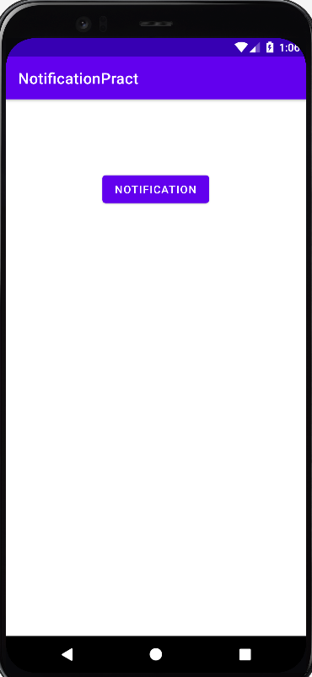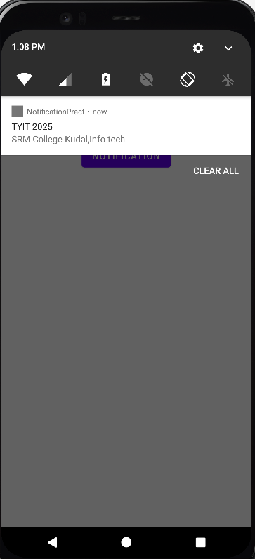

Broadcast receivers
Code:
activity_main.xml
<?xml version="1.0" encoding="utf-8"?>
<androidx.constraintlayout.widget.ConstraintLayout xmlns:android="http://schemas.android.com/apk/res/android"
xmlns:app="http://schemas.android.com/apk/res-auto"
xmlns:tools="http://schemas.android.com/tools"
android:layout_width="match_parent"
android:layout_height="match_parent"
tools:context=".MainActivity">
<TextView
android:layout_width="wrap_content"
android:layout_height="wrap_content"
android:text="Hello World!"
app:layout_constraintBottom_toBottomOf="parent"
app:layout_constraintEnd_toEndOf="parent"
app:layout_constraintStart_toStartOf="parent"
app:layout_constraintTop_toTopOf="parent" />
</androidx.constraintlayout.widget.ConstraintLayout>

MainActivity.kt
package com.example.broadcastpract
import android.content.Intent
import android.content.IntentFilter
import androidx.appcompat.app.AppCompatActivity
import android.os.Bundle
class MainActivity : AppCompatActivity() {
lateinit var modeChecker:Checker
override fun onCreate(savedInstanceState: Bundle?) {
super.onCreate(savedInstanceState)
setContentView(R.layout.activity_main)
modeChecker= Checker()
IntentFilter(Intent.ACTION_AIRPLANE_MODE_CHANGED).also { registerReceiver(modeChecker,it) }
}
}

Checker.kt
package com.example.broadcastpract
import android.content.BroadcastReceiver
import android.content.Context
import android.content.Intent
import android.widget.Toast
class Checker:BroadcastReceiver() {
override fun onReceive(p0: Context?, p1: Intent?) {
var checkStatus=p1?.getBooleanExtra("state",false)?:return
if (checkStatus){
Toast.makeText(p0,"Airplane mode Enable",Toast.LENGTH_SHORT).show()
}
else{
Toast.makeText(p0,"Airplane mode Disable",Toast.LENGTH_SHORT).show()
}
}
}

Output:

